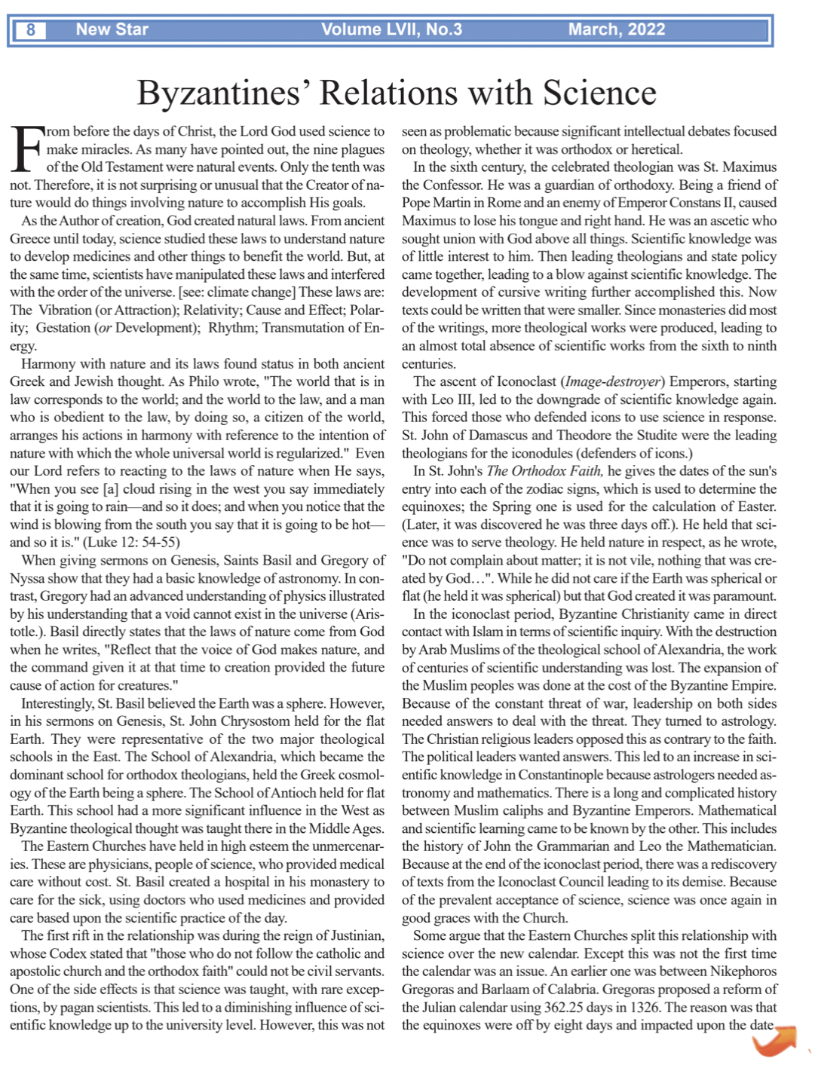
of Easter. This is important because if anything lies in the heart of the Byzantine Church, it is the liturgy. The Church opposed this change, not because of the calendar; the Church was afraid of changing after the attempt of reunification with Rome had failed. Gregoras himself wrote that it was rejected to not “confuse the ignorant or divide the Church.” Gregoras fell out of favor after the death of Andronicus II and the ascension of Andronicus III. Hence, the rise of Barlaam, which showed a more favorable attitude towards things that were Roman or Latin, and at this time both used the same Julian calendar. In the 1920s, some of the Eastern Churches adopted the decision to use the Western (Gregorian) calendar of 1582. It was expressed as a decision to keep the old one, trusting ancient culture more than modern science. There developed a conflict between tradition and modernity. The division of the calendar remains along these lines. There are those who believe tradition and modernity are com-patible and those who do not. In the former, science will still be a tool of the Church, and those who do not see compatibility, may view science in opposition. Fr Jonathan Morse

